Scalable Network I/O: From select to io_uring
Chitiveli Hemcharan Varma  24110095 | Gella Naga Sai Krishna  24110122 | Guransh Kaur Saran  24110127
Kowel P Laloo  24110168 | Pallav Biyala  24110234

I. Introduction
A network server that handles thousands of concurrent TCP connections on a few threads depends on how the kernel tells it which sockets are ready. Linux offers four generations of this interface. select and poll hand the kernel the full set of descriptors on every call and scan it again on return [1]. epoll keeps the interest set in the kernel and returns only ready descriptors [1]. io_uring replaces readiness with shared submission and completion queues, so the application posts operations and later collects their results [2]. The choice affects system-call count, CPU cost per request and latency as the number of connections grows, which is why it matters for scalable services [3].
We built two applications, a TCP echo server and an HTTP/1.1 file-transfer server [6], on one shared core. Each application is compiled against each of the four mechanisms, giving eight binaries; within each application, the four binaries differ in exactly one source file. We then benchmarked them under workloads that vary connection count, offered load, the share of active connections, transfer size and socket options.
Our contributions are: (1) a mechanism-isolated server framework with a single request/callback interface shared by all backends; (2) a benchmarking methodology that controls the variables other than the mechanism, using a two-machine wired testbed with an open-loop load generator for the echo server and a pinned, repeated testbed for the file server; (3) measured results for both applications; and (4) an explicit account of implementation artifacts we found while validating the results, so that mechanism effects are separated from effects of our own code.

II. Problem Statement
Problem. For a single-threaded TCP server pinned to one CPU core, how much do throughput, latency and CPU cost change when only the I/O multiplexing mechanism changes (select, poll, epoll or io_uring), as the number of connections, the offered load, the fraction of active connections and the transfer size vary?
Inputs. Concurrent connections (1 to 10,000), offered load in messages/s or closed-loop clients, the fraction of active connections, message size (512 B echo frames) or file size (4 KiB to 100 MiB), and server options (TCP_NODELAY, buffer and chunk size, epoll and io_uring flags).
Outputs. Throughput (messages or responses/s, MB/s), latency percentiles (p50, p99), sent versus completed rate, server CPU per response (file server) and server-side counters (wake-ups, reads, writes, errors).
Assumptions and constraints. Linux, IPv4, non-blocking sockets, one server thread on one core, commodity laptops. Each mechanism is used in its standard textbook form; every optimisation is an opt-in flag.
Scope. In scope: the four mechanisms, two applications, connection scaling to 10,000 (select only to 900 because of its FD_SETSIZE limit of 1,024 descriptors) and server-option experiments. Out of scope: multi-threaded and multi-core scaling, TLS, HTTP pipelining and zero-copy transmission. Advanced io_uring features (multishot operations, provided and fixed buffers, SQPOLL, zero-copy send) are declared in our flag interface but not yet implemented, so our io_uring results describe its baseline form.
Gap. Comparisons of these mechanisms often use a separate program, library or threading model for each one, so differences in buffering, socket options and concurrency are confounded with the mechanism itself. We hold the application, buffers, socket options, CPU placement and load generator constant and swap a single I/O module, and we report where that isolation is known to be incomplete.

III. Project Objectives
- O1: Implement four interchangeable I/O backends behind one interface and use them unchanged in two applications (8 binaries).
- O2: Verify correctness on all four backends: framed echo with per-message checksums, and HTTP correctness, malformed requests, keep-alive and concurrent clients.
- O3: Measure echo latency and throughput from 50 to 10,000 connections (select to 900) under open-loop and closed-loop load.
- O4: Measure the cost of idle connections (5% to 100% active at 900 and 10,000 connections).
- O5: Quantify server-option effects: epoll maxevents, edge-triggered and one-shot modes, Nagle's algorithm, buffer size and io_uring ring size.
- O6: Measure file-server throughput, latency and CPU per response across concurrency (1 to 1,000), file size, connection reuse, chunk and socket-buffer sizes, slow readers and TCP_NODELAY, with five repetitions.

IV. Architecture and Design
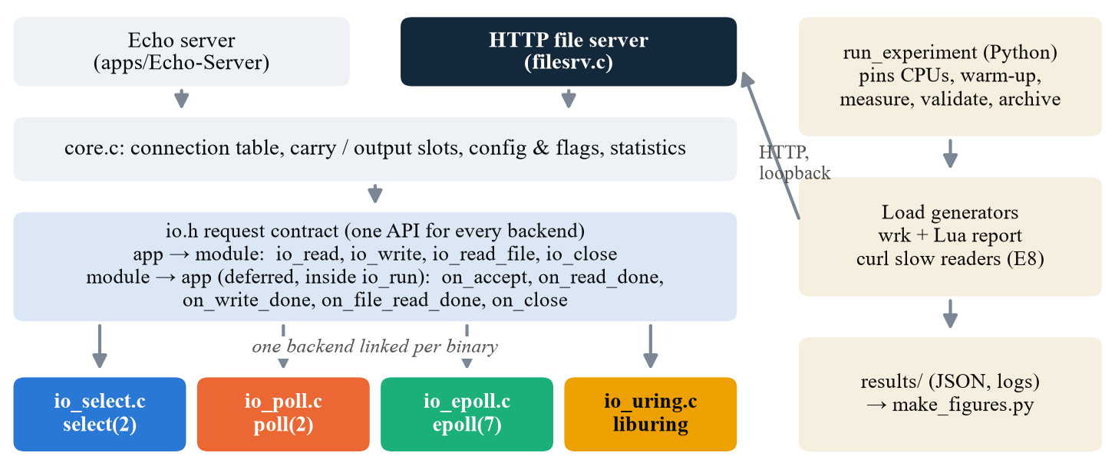
Fig. 1. System architecture. Both applications use the same core and the same io.h contract; exactly one I/O module is linked into each binary.
Components. The applications (echo.c, filesrv.c) contain only protocol logic. The core (core.c) parses and validates flags, owns a connection table indexed by (id, generation), and allocates carry and output buffers from a pool mapped at start-up, so nothing is allocated inside the event loop. It also applies identical socket options to every accepted connection and exports counters on request (SIGUSR1). Each I/O module implements io.h, and one is linked per binary (Fig. 1).
Interface. The contract is a set of I/O requests, not readiness events. The application calls io_read, io_write, io_read_file or io_close, and the module completes the request through a callback (on_read_done, on_write_done, on_close). Readiness modules wait for readiness and then call recv or send. The io_uring module submits RECV and SEND operations. A request that finishes immediately is queued and delivered on the next loop pass, which prevents read→write→read recursion and makes all four modules deliver callbacks the same way. At most one request is in flight per connection, which bounds memory and applies natural backpressure to slow clients.
Baselines. select rebuilds its descriptor sets every loop, scans all registered connections and refuses descriptors ≥ 1,024. poll keeps a compact pollfd array and scans it every loop. epoll is level-triggered: each socket is added once, a send is tried immediately, and interest switches to EPOLLOUT only when a send is incomplete. io_uring keeps one ACCEPT outstanding, posts one RECV or SEND per connection, tags each request with (id, generation) to discard stale completions, and submits and waits once per loop.
Design decisions and trade-offs. We chose isolation over peak performance: every backend is a plain baseline and every optimisation is a flag, so a measured difference can be attributed to one change. The cost is that no backend is tuned, and io_uring in particular is shown below its potential. A single pinned thread exposes the per-core cost of each mechanism but does not measure multi-core scaling. Readiness modules read into one shared scratch buffer, while io_uring needs one buffer per connection because the buffer must exist when the request is submitted; this forces the readiness modules to copy unsent data. Alternatives we rejected were separate servers per mechanism, which confounds the comparison; event libraries such as libevent, which hide the mechanism; and multi-threaded servers, which hide per-core cost.
Applications. The echo server returns data in fixed 512-byte frames and keeps partial frames in a carry slot. The file server answers HTTP/1.1 GET requests for files opened once at start-up. It sends the header, then the body in 64 KiB chunks (io_read_file followed by io_write), and serves keep-alive requests sequentially.

V. Implementation
The servers are written in C17 (about 5,300 lines) with GNU Make and liburing. The echo load generator, echo_loadgen, is a single-threaded C++17 epoll client. Experiment runners and plotting use Bash and Python 3 (pandas, matplotlib). The file server is driven by wrk [7] with a Lua reporter, and slow readers by rate-limited curl. All four modules share the event-loop shape below:
loop until shutdown:
deliver queued completions (callbacks)
timeout = 0 if work is queued, else infinite
wait: select | poll | epoll_wait |
io_uring_submit_and_wait
for each ready socket or completion:
recv/send (readiness) or read CQE result
call on_read_done / on_write_done / on_close
accept new connections; finish queued closes
Each echo message carries a 32-byte header with a nanosecond CLOCK_MONOTONIC timestamp, connection id, sequence number and Adler-32-style checksum. This gives a round-trip time (RTT) per message and detects corruption: every reported run had zero mismatches. In open-loop mode the generator sends on a fixed schedule and records how late it was, so queueing is not hidden by the client slowing down (coordinated omission) [4]. In closed-loop mode each connection keeps a window of W messages outstanding.
Challenges. (1) Buffer lifetime: the readiness modules share one scratch buffer whose data is valid only during the callback, so partial frames are copied to a carry slot and unsent output to an output slot. (2) Callback recursion: immediate completions are deferred to the next loop pass in every module. (3) Stale io_uring completions after a close are rejected by generation tags, and a close waits for in-flight requests. (4) select's descriptor limit is enforced explicitly, and select is tested only up to 900 connections. (5) Benchmark validity: checking the results exposed several artifacts of our own code and procedure, reported in Section VIII-C.
Code repository: https://github.com/Pallav-Biyala/CS331-T008-NetworkIO (branch main).

VI. Testbed Setup

A. Echo server
Two laptops are connected by a direct Ethernet cable with static addresses (server 192.168.50.1, client 192.168.50.2). Server: Intel Core i7-13620H (6 performance and 4 efficiency cores, 16 threads), 16 GB RAM, Ubuntu 26.04.1 LTS, kernel 7.0.0-38-generic. Client: Intel Core i5-13420H (4 performance and 4 efficiency cores, 12 threads), 16 GB RAM, Ubuntu 26.04.1 LTS, kernel 7.0.0-42-generic. Each machine had only that kernel installed at the time of the runs. Both use an onboard Realtek RTL8111/8168 Gigabit Ethernet controller, and the link negotiates 1000 Mb/s full duplex. The server is pinned to one performance core with its SMT sibling left idle, and the load generator to CPU 2, a performance core, on the client.
Controls applied on both machines in every session: Wi-Fi, Bluetooth and background services stopped; CPU governor set to performance on mains power; irqbalance stopped and NIC interrupts moved off the server core and its sibling; Energy-Efficient Ethernet and adaptive interrupt coalescing disabled. The setup scripts also raised kernel limits identically for all backends: accept and SYN backlogs to 16,384, the socket-buffer maximum to 16 MiB, the local port range to 1024–65535, and TIME_WAIT reuse on. GRO, GSO and TSO offloads and TCP autotuning were left on.
Workload. 512-byte messages; 5 s warm-up, 20 s measurement and 5 s cool-down per case; 66 cases per backend (41 for select). The suites are S1 connection scaling from 50 to 10,000 connections at 1k and 10k msgs/s (open loop) plus a closed-loop ceiling, S2 offered-load sweep, S3 active share, S4 pipeline window and S5 arrival distribution. One repetition per backend was run, and one server process served all cases of a backend. Server-option variants were run in later sessions with a 30 s measurement window.

B. File server
One laptop: Intel Core i5-10300H (4 cores / 8 threads), WSL2 with 8 GB of memory and Linux 6.18.54, loopback (127.0.0.1). The server is pinned to CPU 1 and wrk to CPUs 2–5 (1 thread for 1 connection, 2 for 10, and 4 otherwise). Each case uses 10 s warm-up, 30 s measurement (90 s for E8) and 10 s cool-down, and is repeated five times in a seeded random order; we report the median and interquartile range. The files are deterministic fixtures of 4 KiB, 64 KiB, 1 MiB, 4 MiB and 100 MiB, sent in 64 KiB chunks with a 64 KiB application buffer (256 KiB in E7). Each run is accepted only if the client output and server counters validate; 357 of 360 runs were accepted.
TABLE I
Controls in the two testbeds
Control | Echo | File server
Same app and core; one I/O module swapped | Yes | Yes
Identical socket options (one function) | Yes | Yes
Single server thread, pinned | Yes (sibling idle) | Yes (CPU 1)
Client on a separate machine | Yes | No (CPUs 2–5)
Network | Direct Ethernet | Loopback (WSL2)
Load model | Open and closed loop | Closed loop (wrk)
Governor, IRQ and radio controls | Yes | No
Identical kernel tuning for all backends | Yes (raised limits) | Yes (defaults)
Run order | Fixed, one backend at a time | Seeded random
Repetitions | 1 (noise estimated) | 5 (median, IQR)
Server CPU recorded | No | Yes

Because the testbeds differ, absolute numbers are compared only within an application, never across the two.

VII. Evaluation

A. Echo server
Validity. With one repetition, we estimated noise from configurations that were measured more than once. Throughput repeated within 0.3% in a session and 0.6% across sessions. Median latency is far noisier: the same case drifted by −16% to +21% between the start and end of a session, and differed by up to 27% between sessions. We therefore treat throughput differences above 1% and latency differences above about 30% as findings.
Connection scaling (Fig. 2). At a fixed 10k msgs/s with all connections active, epoll's median RTT stays at 54–56 µs from 50 to 10,000 connections, the behaviour expected when the kernel returns only ready sockets. select rises from 64 µs at 50 connections to 178 µs at 900, consistent with rebuilding and scanning the whole descriptor set on every call, and it cannot go beyond 1,024 descriptors. io_uring stays roughly flat, but at 80–191 µs, 1.5–3.4× epoll's latency. poll grows about 4× each time the connection count doubles (1.7 ms at 900, 271 ms at 10,000). That is quadratic, not poll(2)'s linear cost: our poll module finds each pollfd's connection with a linear scan of the connection table (core_conn_by_fd) several times per loop, which makes each loop O(n²). We show poll for completeness but do not read these numbers as properties of poll.
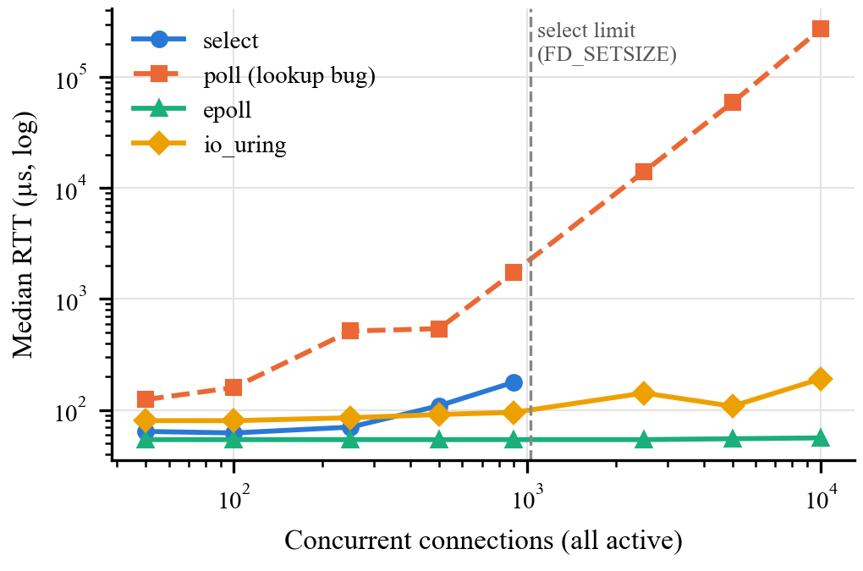
Fig. 2. Echo median RTT vs. connections at a fixed offered load of 10k msgs/s (open loop). Dashed: poll, dominated by our lookup bug.
Idle connections (Table II). At 5k msgs/s, epoll's latency is the same whether 5% or 100% of connections are active, at both 900 and 10,000 connections, so idle sockets cost epoll nothing. io_uring is also insensitive to the active share but slower with more registered connections (103 µs at 900, 142 µs at 10,000). select's latency depends on how many descriptors are registered, not how many are active, as expected from its full scan.
TABLE II
Median RTT (µs) at 5k msgs/s vs. active share
Backend, connections | 5% active | 100% active
select, 900 | 167 | 172
epoll, 900 | 54 | 54
epoll, 10,000 | 56 | 64
io_uring, 900 | 103 | 103
io_uring, 10,000 | 142 | 143

Throughput ceiling (Fig. 3). In closed loop with one message outstanding per connection, select, epoll and io_uring all reach 131.2k–131.4k echoes/s, within 0.2% of each other, from 50 to 900 connections; epoll and io_uring still reach 125k at 10,000. With a window of 8 the ceiling rises to 175k–177k for all three. Because three very different mechanisms stop at the same value, the limit is not the mechanism. The client's CPU stayed at or below 44%, so the load generator's CPU is not the limit either (Section VIII-C).
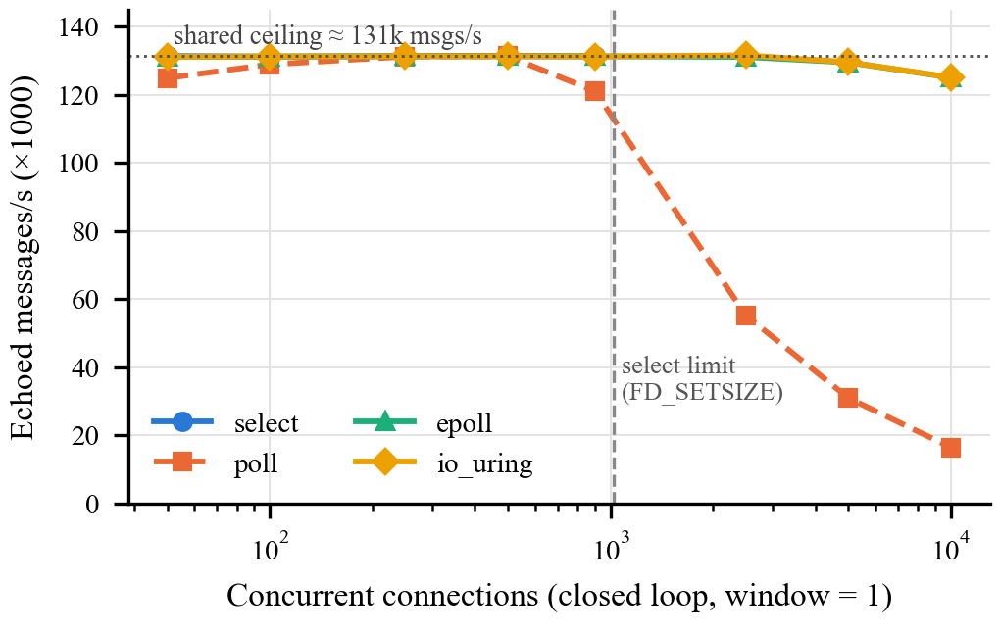
Fig. 3. Echo closed-loop throughput vs. connections (window 1). select, epoll and io_uring overlap at the shared ceiling.
Server options (Table III). Limiting epoll to one event per wake-up (--epoll-maxevents=1) cuts the ceiling by 56% at 500 connections and 84% at 10,000, because every ready socket then costs a separate epoll_wait call. This shows the value of returning many events per wake-up. Reducing the read buffer to 512 B lowers the window-8 ceiling by 16%, because pipelined frames now need more recv calls. Turning Nagle's algorithm on lowers the window-8 ceiling by 3–9%. Edge-triggered and one-shot epoll and a smaller io_uring ring (256 entries) had no effect beyond noise. The variant sessions used a 30 s instead of a 20 s measurement window, so we compare only throughput, which is stable to within 1% across sessions.
TABLE III
Echo server-option effects (echoes/s)
Option (backend) | Baseline | Variant
maxevents=1, 500 conns, W=1 (epoll) | 131.4k | 57.6k (−56%)
maxevents=1, 10k conns, W=1 (epoll) | 125.1k | 19.8k (−84%)
buf-size 512, W=8 (epoll) | 176.8k | 147.8k (−16%)
Nagle on, W=8 (epoll / select / io_uring) | 176.8k / 177.4k / 174.9k | −3% / −4% / −9%
ET, one-shot (epoll); 256-entry ring (io_uring) | — | no effect

Bursts. At the same mean rate (15k msgs/s, 500 connections), 4× bursts raise the p99 RTT from about 0.1 ms to about 13 ms on every backend. The arrival pattern dominates the tail far more than the mechanism does. Burst p99 varied between 2.5 and 12.5 ms in identical runs, so we draw only this qualitative conclusion.

B. File server
Concurrency (Fig. 4). For 4 KiB files, going from 1 to 100 connections raises throughput by about 37% (4.3k → 5.9k–6.0k responses/s) on every backend. At 1,000 connections epoll serves 5,484/s, io_uring 5,460/s, select 5,392/s and poll 4,989/s (−9%). Mean latency follows Little's law (100 / 5,925 ≈ 17 ms). io_uring's p99 latency at 1,000 connections is 13.5 s, against 0.24 s for epoll (Section VIII-C).
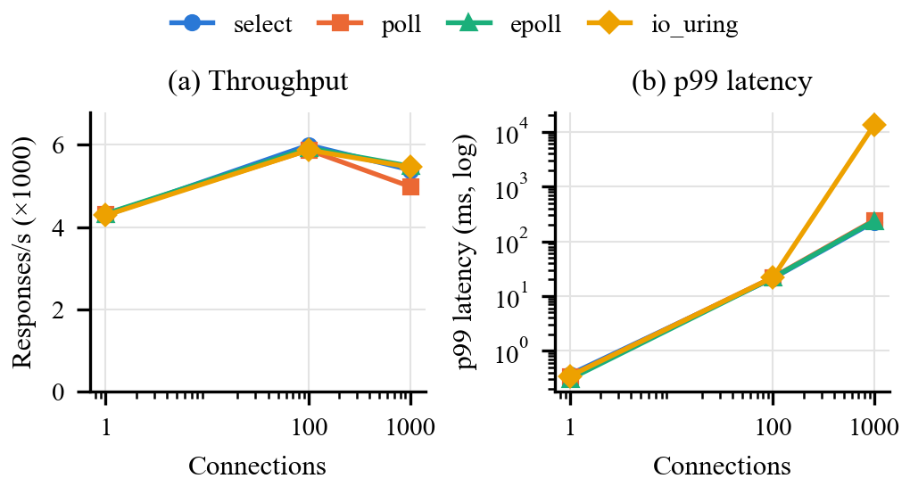
Fig. 4. File server, 4 KiB file: (a) throughput and (b) p99 latency vs. connections (median of 5 runs).
Why the backends tie. The server core was at most 48% busy in every test. Most of its time went to kernel copying through TCP; user space accounted for about 2% (8.6% for poll at 1,000 connections). Large files (64 KiB to 100 MiB) all reach about 170 MB/s on every backend. The limit is therefore outside the server, most likely wrk on two physical cores and the WSL2 loopback path, and throughput cannot separate the backends on this testbed.
CPU per response (Table IV). io_uring uses 12–13% less CPU per response on large files, but mostly because our readiness modules stage each 64 KiB chunk in a slot and copy it, while io_uring reads straight into the send buffer. This is an implementation difference, not a mechanism effect. poll's +27% at 1,000 connections comes from the same lookup bug as in the echo server. io_uring costs 15% more when every response uses a new connection, likely because of extra per-connection setup, which we did not investigate.
TABLE IV
Server CPU per response relative to epoll
Workload | select | poll | io_uring
4 KiB, 100 conns | −3% | +1% | −9%
4 KiB, 1,000 conns | +4% | +27% | −7%
4 KiB, close, 100 conns | −10% | +2% | +15%
1 MiB / 4 MiB / 100 MiB | −2 to 0% | −1 to +2% | −12 to −13%

Protocol and socket settings (Table V). These matter far more than the backend. Turning TCP_NODELAY off cuts 4 KiB throughput by 62% on all four backends. The header and body are two separate writes: Nagle's algorithm [5] holds the body until the header is acknowledged, and the client delays that ACK by about 40 ms (100 connections / 44 ms ≈ 2,270/s, as measured). 16 KiB chunks cost 41% of throughput, while socket-buffer sizes have no effect. One hundred slow readers (100 KiB/s each) cost the 100 fast clients 7–11%, because every non-blocking backend keeps serving other sockets while a slow reader's buffer is full. The keep-alive gain (0% for select, +5 to +8% for the others) is no larger than the 7–12% variation between sessions, so it is inconclusive.
TABLE V
File-server settings (median, all backends)
Experiment | Result
TCP_NODELAY off, 4 KiB | 5.9k → 2.27k req/s; 17 → 44 ms
TCP_NODELAY off, 64 KiB | no change (~2.56k req/s)
16 KiB chunks, 4 MiB file | 169 → 99 MB/s (−41%)
SO_RCVBUF 512 KiB / SO_SNDBUF 64 KiB | no change (~169 MB/s)
10 / 100 slow readers | no change / −7 to −11%*
Keep-alive vs. close | 0 to +8% (inconclusive)

*Run 3 at 100 slow readers was rejected on three backends because no download finished within 90 s, so those cells have n = 4 and are optimistic.

C. Observations under investigation
The following results are not yet fully explained. For each we give what we think is happening and the next step.
- io_uring p99 of 13.5 s at 1,000 connections (file server). We think this is an accept bottleneck rather than unfair completion handling. Our baseline keeps one ACCEPT outstanding and re-arms it once per loop, about 57 times per second at this load, so accepting 1,000 connections takes about 17 s, which matches wrk's 17.8 s maximum latency. About 1,000 warm-up connections were still being accepted and reset inside the measured window, which supports this. Next: multishot or batched accept, and a separation check between warm-up and measurement.
- io_uring echo latency is 1.5–3.4× epoll's. We have not isolated the cause. Our baseline posts one request at a time per connection and does one submit-and-wait per loop. It also scans every connection slot each loop, but the epoll module does the same, so that scan alone cannot explain the gap. Next: profile with perf, then add multishot receive and provided buffers.
- Shared echo ceiling. With one message outstanding, select, epoll and io_uring stop at about 131k msgs/s from 50 connections upward. It is not the client CPU (at most 44%), and it is not packet loss: there are no retransmissions at 50–250 connections, and they appear only from about 500. With a window of 8 the ceiling rises to 175k–177k msgs/s, about 725 Mb/s of payload in each direction, so per-packet headers may bring that ceiling close to the 1 Gb/s link. The window-1 ceiling is well below line rate and remains unexplained; we did not record server CPU. Next: record server CPU and softirq time, and wire bytes from interface counters, per run.
- Higher latency at low load. epoll's median is 91 µs at 1k msgs/s but 54 µs at 10k msgs/s; select and io_uring behave the same way. The governor was fixed, so we think deep CPU idle states (C-states) add wake-up delay between sparse packets. Next: limit C-states and repeat.
- poll slows down during a session. One server process ran all cases. After the 10,000-connection cases, the connection table is fragmented and poll's linear lookups take longer: the same 500-connection case measured 104 µs early in the session and 1.7 ms later. Next: store the connection pointer per pollfd entry and restart the server for each case.

VIII. Summary
We compared select, poll, epoll and io_uring in two TCP servers that share all code except one I/O module, on testbeds designed to hold other variables constant. For the echo server, epoll's latency stayed flat from 50 to 10,000 connections and idle connections cost it nothing. select was competitive up to 900 connections but scales with the number of registered descriptors and stops at 1,024. Baseline io_uring matched epoll's throughput but had 1.5–3.4× its latency. Returning only one event per epoll wake-up cut throughput by up to 84%. For the file server, all four backends tied on throughput because the server core was never saturated. TCP-level settings, Nagle's algorithm (−62%) and chunk size (−41%), mattered far more than the mechanism, and CPU per response differed by up to 15% (excluding poll's lookup bug), partly for implementation reasons.
Limitations: one echo repetition, with one server process per backend; a quadratic lookup in our poll module; an extra file-data copy in the readiness modules; servers built without compiler optimisation (-O0); no server CPU data for the echo server; a single-machine, loopback, closed-loop file-server testbed; and io_uring tested only in its baseline form. Future work: fix the poll lookup and the extra copy and build with -O2; run five echo repetitions, restarting the server for each case; record server and client CPU; cap the server with a cgroup CPU quota so that it, not the client, is the bottleneck; implement multishot, provided-buffer and SQPOLL io_uring modes; and rerun the file server on two machines with fixed-rate load.

IX. Reproducibility
GitHub: https://github.com/Pallav-Biyala/CS331-T008-NetworkIO (branch main). On Ubuntu, install build-essential pkg-config liburing-dev python3 curl wrk. Run every command from the repository root.
Build and test. make builds all servers and the load generator; make test runs the file-server correctness checks. The echo correctness gate is run separately with the four echo binaries:
make -f code/Makefile
make -f code/Makefile test
python3 code/tests/echo_gate.py \
--select ./build/echo-select \
--poll ./build/echo-poll \
--epoll ./build/echo-epoll \
--uring ./build/echo-uring
Echo server. Prepare both machines with code/docs/Echo-Server/linux_network_i_o_benchmark_setup_guide.md. Start one backend on the server, run the case matrix from the client, then plot:
./build/echo-epoll --port 8080 --cpu 2
HOST=192.168.50.1 CLIENT_CPU=2 \
./code/tools/Echo-Server/run_experiment.sh \
--mechanism epoll --full --rep 1
python3 code/tools/Echo-Server/plot_results.py
Raw results: code/results/Echo-Server/ (one folder per backend run, with manifest.txt, results.csv and per-case JSON). The reported data use select_rep1_20261105_170113, poll_rep1_20261105_172543, epoll_rep1_20261105_180001 and uring_rep1_20261105_183701. A later poll rerun (poll_rep1_20261105_201454) is also stored; plot_results.py keeps the most recent run per case, so that rerun must be moved out of the results folder to reproduce Figs. 2 and 3.
File server. Generate the fixtures, then run one configuration per experiment (E5a, E5b, E7, E8, E9 under code/tools/File-Transfer-Server/configs/):
make -f code/Makefile bench-fixtures
python3 code/tools/File-Transfer-Server/run_experiment \
code/tools/File-Transfer-Server/configs/\
filesrv-e5a-size-concurrency.json
Raw results: "code/results/File Transfer Server/benchmarking-results/" (the path contains spaces, so quote it in a shell). The figure script is code/benchmarking-graphs/file-transfer/make_figures.py; it computes the repository root from its original location, so its ROOT line must point to the repository root before it is run.

References
[1] M. Kerrisk, “select(2), poll(2) and epoll(7),” Linux Programmer’s Manual. [Online]. Available: https://man7.org/linux/man-pages/
[2] J. Axboe, “Efficient IO with io_uring,” kernel.dk, Oct. 2019. [Online]. Available: https://kernel.dk/io_uring.pdf
[3] D. Kegel, “The C10K problem,” 2006. [Online]. Available: http://www.kegel.com/c10k.html
[4] G. Tene, “How NOT to measure latency,” presented at QCon, San Francisco, CA, USA, 2015.
[5] J. Nagle, “Congestion control in IP/TCP internetworks,” RFC 896, Jan. 1984.
[6] R. Fielding, M. Nottingham, and J. Reschke, “HTTP/1.1,” RFC 9112, Jun. 2022.
[7] W. Glozer, “wrk: a HTTP benchmarking tool.” [Online]. Available: https://github.com/wg/wrk
Appendix A: Team Work Distribution and Member Rating

A.1 Work Distribution
- Ratings are agreed by the whole team and are unique: no two members receive the same rating.
- Scale: 1–10 (10 = highest contribution).

# | Member Name | Roll No. | Tasks Done | Rating (1–10, unique)
1 | Chitiveli Hemcharan Varma | 2411095 | Echo server benchmarking: load generator, experiment runner, plotting and analysis | 9
2 | Gella Naga Sai Krishna | 24110122 | io_uring backend; file-server benchmark runs, debugging and analysis | 10
3 | Guransh Kaur Saran | 24110127 | select backend; echo server | 7
4 | Kowel P Laloo | 24110168 | Echo server benchmarking: load generator, experiment runner, plotting and analysis | 8
5 | Pallav Biyala | 24110234 | epoll backend; HTTP file-transfer server, correctness tests and benchmarking | 6

Appendix B: AI Usage Details

B.1 Prompts
Prompts and chat logs for the most significant uses are listed below and stored in the repository's ai/ folder.
# | AI Tool | Purpose
1 | ChatGPT (Classic and Codex, OpenAI) | Concept clarification, debugging, documentation and report structuring (ai/Pallav-Biyala/)
2 | Claude in Antigravity | Code generation and review for the file server, finding benchmark-failure bugs, analysis report and slides (ai/Sai-Krishna/Antigravity/, ai/Pallav-Biyala/)
4 | Trae AI | Debugging and correctness-gate support (ai/Pallav-Biyala/TraeAI.md)
5 | GitHub Copilot, Gemini | Code suggestions; io_uring and I/O-model concepts (ai/Sai-Krishna/)
6 | Claude (Claude Code) | Design Plan formulation (ai/Guransh Saran/), repository audit, result-validity checks and drafting of this report
7 | ChatGPT(Classic) | Echo Server–Client Benchmark Setup Guide (ai/Hemcharan Varma/)
8 | Gemini | Conceptual understanding and Decision making for setup (ai/Kowel/)
9 | Claude | Code generation and debugging assistance (ai/Guransh Saran/)

Relevant prompt queries and response .md files are shared in the GitHub ai/ folder.md

